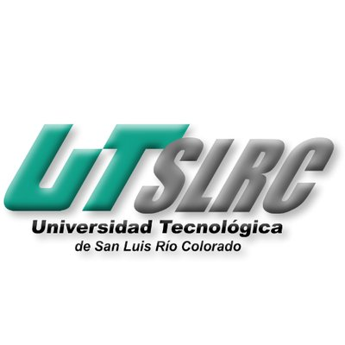

**UNIVERSIADAD TECNOLÓGICA DE**

**SAN LUIS RIO COLORADO**

**ENTREVISTA**

**MTRO. RICARDO ALEJANDRO SOTO MORALES**

**TI 2-4**

**AUTORES:**

**ESPINO TRIGUERAS LEONARDO SAHID**

**GALVAN COVARRUBIAS VICTOR MANUEL**

**MEZA ALVAREZ JUAN**

**PARRA SANCHEZ LESTAT**

**VEGA SAUCEDA ALAN GUADALUPE**

San Luis Rio Colorado, Sonora Mayo, 2020

**https://youtu.be/ha5sNdLDMT0**

**What is an interview?**

* Refers to a one-on-one conversation between an interviewer and an interviewee, where the interviewer asks questions to which the interviewee responds.
* Interviews can happen in a wide variety of contexts like employment, psychology, research, journalism and other media.
* It is used as an information gathering tool as allows the interviewer to stack the questions to get answers to its interest topics.

**STRUCTURE**

* Arrival: punctuality and respect.
* Introduction: Strong handshake and security.
* Information Exchange: basic language questions and formality.
* Farewell: gratitude.

**Attitudes**

* Empathy
* Warmth
* Flexibility
* Eye contact
* Hand gestures
* Know how to listen

**PREPARATION**

* Goal.
* Research.
* Locate source available.
* Place.
* Set date/time.
* Etiquette.
* Take notes and/or record.

**Extraction**

All information is important but only what is necessary should be extracted.

You can't take too much information for just one question.

When extracting the information, you should focus on:

Interesting comments and also answers to very big questions.